PROJECT BASED LEARNING (PBL)
SMARTLIBRARY — INTELLIGENT DIGITAL LIBRARY PLATFORM
PROJECT DOCUMENTATION

Field | Details
Project Type | Java-based console application
Core Language | Java 17+
Build / Test Tools | Maven configuration and JUnit 5 tests
Interface | Command-line menu
Persistence | CSV files on local file system
Academic / Course Details | Fill in course code, faculty, section, and academic year as applicable

Team Members
S.No. | Student Name | Roll No. | Role / Contribution
1 | N. Sujith | 2500031904 | Project integration and library workflow
2 | M. Manikanta | 2500031428 | Algorithm implementation and testing
3 | K. Karthik | 2500031113 | Core development and documentation

Project title: SmartLibrary — Intelligent Digital Library Platform.
Note: Confirm the individual contribution assignments above with the team before submission.

1. Problem Statement and Objectives

1.1 Problem Statement
Library systems need reliable ways to organize book records, track available copies, manage borrowing and returns, and support efficient searching. SmartLibrary is a Java-based console application that combines basic library operations with demonstrations of algorithms commonly studied in computer science. It uses a modular structure and CSV-based persistence so records can be retained between runs.

1.2 Objectives
- Provide menu-driven book management, including adding, listing, searching, updating, and deleting books.
- Track book availability and maintain borrowing, return, and reservation records.
- Persist books and transaction records using CSV files.
- Demonstrate string-search algorithms on book titles and descriptions.
- Use dynamic programming to plan book selections under a reading-time budget.
- Demonstrate network flow, optimization, randomized algorithms, and parallel computation.
- Provide a simple educational comparison of algorithm behavior and runtime measurements.

1.3 Scope
The application is designed as an educational command-line project. It is not a website, REST API, or production library-management platform. Some algorithms are implemented as independent demonstrations and do not directly change the library inventory. Advanced algorithm families listed as future enhancements must not be represented as completed features unless verified in the source code.

2. System Architecture
Figure 1 presents the high-level architecture of SmartLibrary, showing the console entry point, service logic, domain models, algorithm modules, repository interface, and CSV persistence.
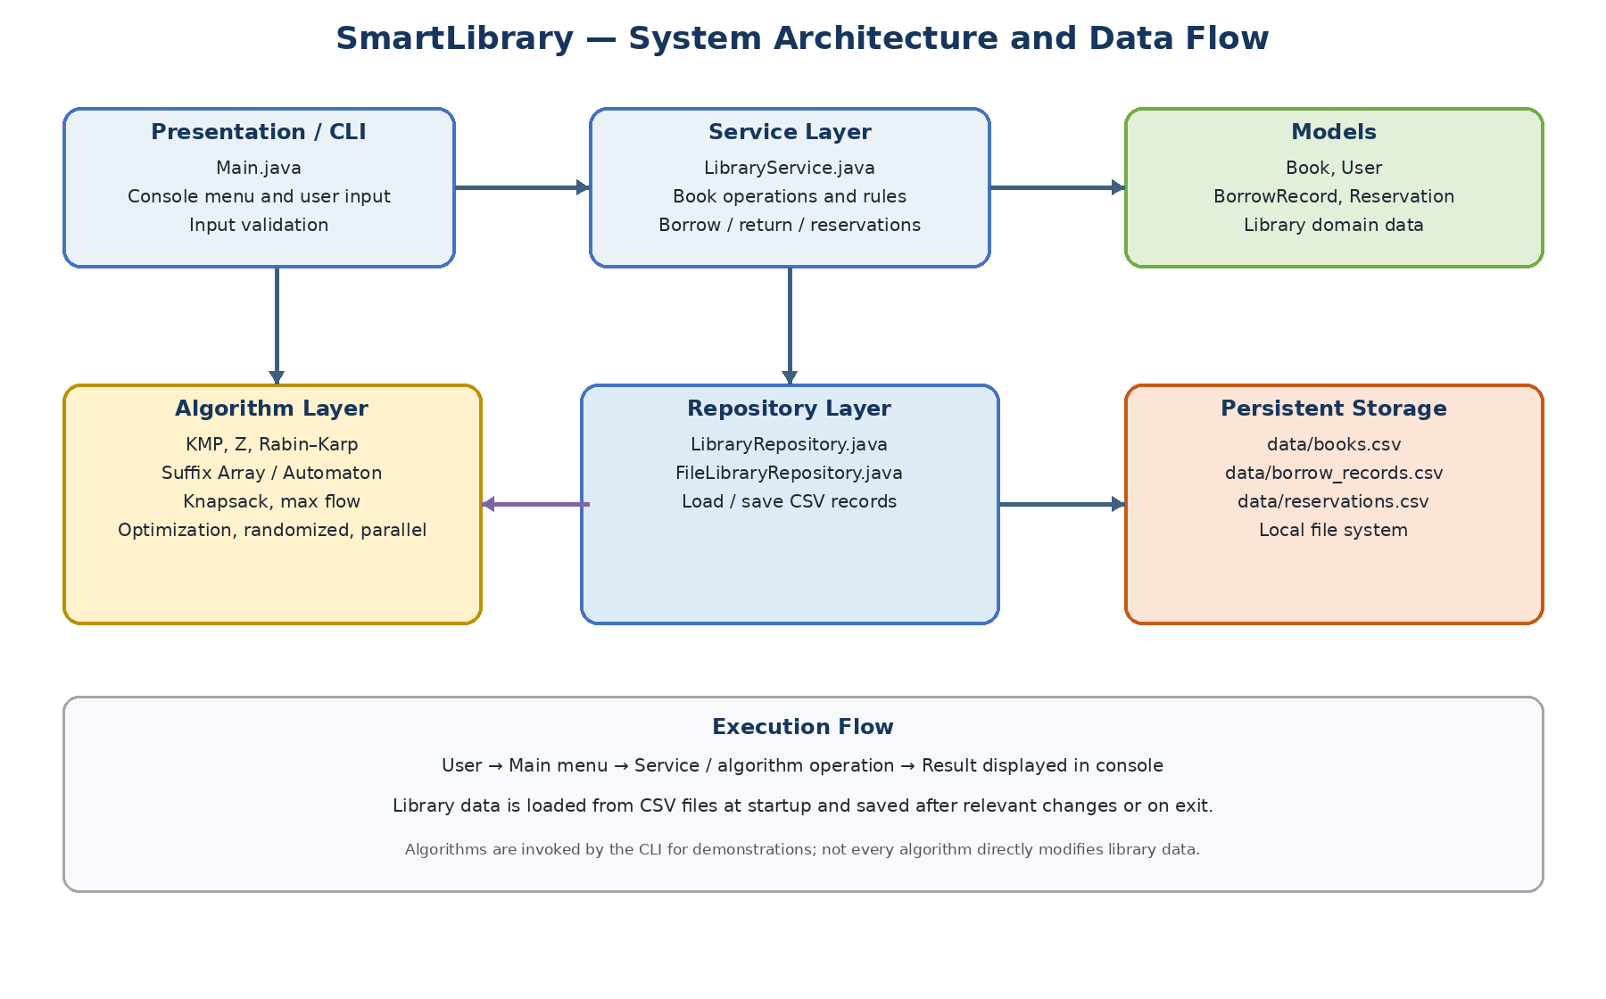
Figure 1. SmartLibrary System Architecture and Data Flow.

2.1 Architecture Explanation
- Presentation layer: Main.java displays the menu, reads user input, dispatches selected actions, and prints results.
- Service layer: LibraryService applies library rules, loads the current book collection, and coordinates add, delete, borrow, return, search, and reservation operations.
- Model layer: Book, User, BorrowRecord, and Reservation represent the principal domain entities.
- Algorithm layer: String-matching classes support pattern search; BookKnapsack plans selections under a time budget; EdmondsKarp calculates maximum flow; Optimization demonstrates exact and approximate methods; randomized and parallel packages provide independent demonstrations.
- Repository layer: LibraryRepository defines persistence operations, while FileLibraryRepository reads and writes CSV files under the data directory.
- Storage layer: books.csv, borrow_records.csv, and reservations.csv persist the current implementation's principal data. The repository code should be checked before claiming that every listed file, including users.csv, is loaded at runtime.

2.2 Main Execution Flow
- The application starts and constructs the file repository and LibraryService.
- LibraryService loads saved books, borrowing records, and reservations; sample books are seeded if the book collection is empty.
- The user selects an operation from the console menu.
- The relevant service or algorithm executes and displays the result.
- Changes are saved to CSV when the operation saves data, when the user chooses Save Data, or on exit.

3. Technology Stack
Category | Technology | Purpose
Programming language | Java 17 or newer | Application logic and algorithms
Build configuration | Maven (pom.xml) | Dependency and build configuration; optional for manual compilation of dependency-free main sources
Testing | JUnit 5 | Automated regression tests
Persistence | CSV files | Local storage for books and transaction records
Version control | Git / GitHub | Source tracking and collaboration
Execution model | Console / CLI | Menu-driven interaction without a web frontend

4. Module Description
No. | Module | Purpose / Key classes
1 | Console menu | Main.java; input, menu navigation, result output
2 | Book management | LibraryService; Book; CRUD and search operations
3 | Persistence | LibraryRepository; FileLibraryRepository; CSV read/write
4 | String search | KMP, ZFunction, RabinKarp, SuffixArray, SuffixAutomaton
5 | Reading planner | BookKnapsack; maximize learning value within a time budget
6 | Flow and optimization | EdmondsKarp; exact knapsack and vertex-cover approximation
7 | Randomized algorithms | RandomizedQuickSort; MillerRabin
8 | Parallel algorithms | ParallelPrefixSum; ParallelReduce
9 | Benchmarking | AlgorithmBenchmark; basic timing and result comparison

5. Implementation Details

5.1 Book Management and Persistence
The console interface supports adding, listing, searching, updating, and deleting book records. Borrowing decreases the available-copy count; returning increases it and can fulfill the next active reservation for the book. CSV persistence is managed through FileLibraryRepository. The demo user ID used by the service is U001.

5.2 Smart Pattern Search
The search module applies selected string algorithms to a combined string containing each book title and description. KMP uses a longest-prefix-suffix table; the Z-function computes prefix matches; Rabin–Karp uses rolling hashes with character verification; suffix-array operations provide suffix ordering and LCP information; and the suffix automaton supports substring membership queries.
Algorithm | Typical complexity / note | Purpose
KMP | O(n + m) time; O(m) prefix table | Find pattern occurrences
Z-Function | O(n + m) time and space | Find matches via Z values
Rabin–Karp | Expected O(n + m); worst case O(nm) | Rolling-hash pattern search
Suffix Array / LCP | Current educational suffix sorting is slower than optimized approaches | Suffix ordering and repeated-prefix information
Suffix Automaton | Expected linear construction with hash-map transitions | Substring membership testing

5.3 Intelligent Reading Planner
BookKnapsack applies a 0/1 knapsack dynamic-programming approach. Each book has a reading-time cost and learning-value score. Given a time budget B, the planner chooses a subset whose total time does not exceed B while maximizing the sum of learning values. The implementation uses O(nB) dynamic-programming work and currently caps the number of books for practical reconstruction. If all books exceed the supplied time budget, the correct result can be an empty plan with zero minutes and zero value.

5.4 Resource Allocation and Optimization
EdmondsKarp demonstrates maximum flow using an integer capacity matrix. Optimization contains a brute-force exact knapsack demonstration and a greedy edge-picking approximation for vertex cover. The console also explains P, NP, NP-hard, NP-complete, and the conceptual 3-SAT-to-Vertex-Cover reduction. These educational examples should not be interpreted as a complete production allocation engine.

5.5 Randomized and Parallel Algorithms
RandomizedQuickSort uses a seeded pseudorandom pivot selection, making example runs reproducible. MillerRabin implements a probabilistic primality test. ParallelPrefixSum compares a sequential prefix scan with a chunked parallel version, and ParallelReduce compares sequential and parallel summation. Parallel overhead may make the parallel version slower for small inputs.

5.6 Performance Comparison
AlgorithmBenchmark runs KMP, the Z-function, and Rabin–Karp on the same input and reports elapsed nanoseconds and basic operation counters. This is an educational microbenchmark rather than a statistically rigorous benchmark; JVM warm-up, garbage collection, and system load can affect timings.

6. Testing Methodology
The repository includes JUnit 5 tests for agreement among string-matching algorithms, suffix-array and suffix-automaton behavior, maximum-flow results, randomized sorting, parallel prefix-sum equivalence, and vertex-cover validity. Run the test suite with Maven when Maven is installed.
Test area | Expected behavior
String matching | KMP, Z-function, and Rabin–Karp return matching positions for the same sample input.
Suffix structures | Suffix array returns one suffix index per character; suffix automaton answers substring membership.
Maximum flow | Edmonds–Karp returns the known maximum flow for a small directed graph.
Randomized sorting | Output is sorted in ascending order, including duplicates and negative numbers.
Parallel prefix sum | Sequential and parallel prefix arrays are equal.
Vertex cover | The produced cover includes at least one endpoint of each supplied edge.

Suggested commands: mvn clean test, followed by mvn exec:java. Manual compilation can be used for the main sources if Java is installed and no external dependencies are needed, but JUnit tests require JUnit on the test classpath.

7. Results and Discussion
The application integrates library workflows with several algorithm demonstrations in one console program. Its modular packages separate models, services, repositories, and algorithm implementations. CSV storage keeps the application simple to run and inspect. Actual results depend on the books present in the data directory and on the chosen input. No benchmark speedup or external evaluation result is claimed in this document.

7.1 Strengths
- Simple menu-driven interface suitable for demonstrations.
- Persistent records stored in readable CSV files.
- Separation between library business rules and algorithm examples.
- A range of algorithmic techniques suitable for a data-structures and algorithms project.
- Regression tests for selected core algorithms.

7.2 Limitations
- The interface is a console menu rather than a graphical application.
- CSV files are intended for a small educational application and do not provide database-level transaction guarantees.
- Some advanced algorithm concepts are explanatory or future enhancements rather than full integrated modules.
- The benchmark is a simple single-run comparison, not a rigorous performance study.
- The reading planner selects whole books and cannot model partial-book reading sessions.

8. Future Enhancements
- Add chapter-level or partial-book planning for shorter study sessions.
- Add robust CSV escaping, stronger validation, and transactional persistence.
- Add richer recommendation logic based on user interests and borrowing history.
- Implement and test additional DP variants, Dinic, and a complete flow-allocation workflow where required by the project specification.
- Use JMH or repeated warm-up trials for more reliable performance measurement.
- Expand automated tests for repository errors, invalid inputs, reservations, and borrowing edge cases.

9. Conclusion
SmartLibrary demonstrates how a Java console application can combine basic digital-library operations with algorithmic problem solving. The layered structure separates the user-facing menu, service rules, data models, algorithm demonstrations, and CSV persistence. The project provides a foundation for future improvements in planning, recommendations, testing, and performance measurement.

10. References
- Java Platform documentation: https://docs.oracle.com/en/java/
- Apache Maven documentation: https://maven.apache.org/guides/
- JUnit 5 User Guide: https://junit.org/junit5/docs/current/user-guide/
- Thomas H. Cormen et al., Introduction to Algorithms, MIT Press.
- SmartLibrary source code and README in the project repository.

Appendix A. Example Console Menu
1 Dashboard and Statistics
2 Book Management
3 Smart Pattern Search
4 Intelligent Reading Planner
5 Borrowing and Resource Allocation
6 NP-Completeness and Optimization Lab
7 Randomized Algorithms
8 Parallel Algorithms
9 Algorithm Performance Comparison
10 Save Data
0 Exit

